Linda Mei

Final Project: Piece 2 JFreeChart and Apache Plotter, Salter, and Smoother

I took my existing equation, graph ranges, and salting ranges directly from my Project 1’s Graph program to ensure that I get similar results when I use JFreeChart and the Apache Maths (Stats) Library. I used the same smoothing ranges as the ones I used for Octave. On an unrelated note, I am glad I did not give up Piece 2, and I am happy that I got my program to work.

I used the Apache Maths (Stats) Library API and JFreeChart API. An external resource I used was the JFreeChart Quick Guide which simplified the JFreeChart API down and included the Line Chart example that I could refer to. I also levied off of my previous FishMarket and GraphProgram’s FileReader and FileBuffer which I used the FileReader and FileWriter links below as a reference. I have these links cited commented out at the top of my code as well.

Works Cited

1. <https://www.tutorialspoint.com/jfreechart/jfreechart_quick_guide.htm>
2. <https://howtodoinjava.com/java/io/java-filereader/>
3. <https://www.geeksforgeeks.org/filewriter-class-in-java/>

**Plotter Graph 1**

Equation: y = 6x+9

Range: 1 - 100 points

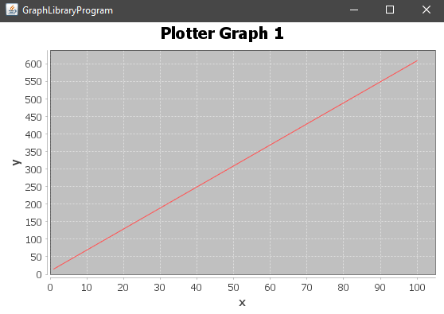

**Salter Graph 1**

Salted the y-values with a random range of 25 to 60

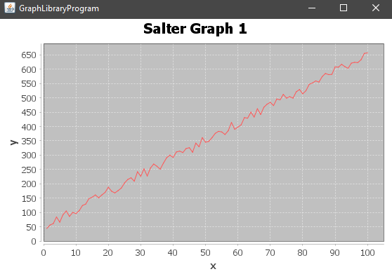

**Smoother Graph 1**

Smoothed the graph (sliding window length: 25)

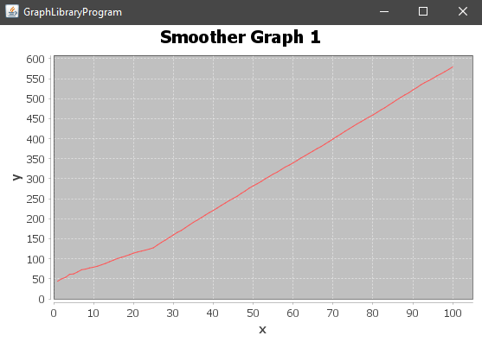

**Plotter Graph 2**

Equation: y = 6x+9

Range: 1 - 10000 points

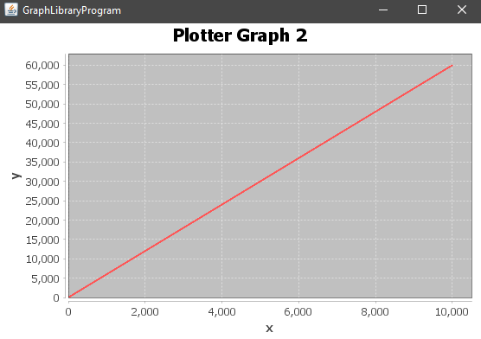

**Salter Graph 2**

Salted the y-values with a random range of 2500 to 7500

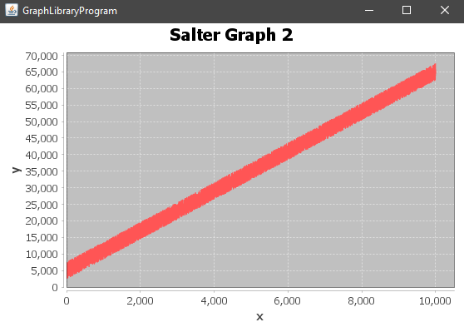

**Smoother Graph 2**

Smoothed the graph (sliding window length: 2500)

